
Copley township
pigeon creek mucd

MAJOR SITE PLAN
staff report working doucment*
  - August 4, 2025

applicant summary
ARCHITECTURAL REVIEW BOARD
- Major Site Plan Application: Submitted 8/4/2025

Required Documents:
- Wetland Delineation-In Progress to Army Corp anticipate receipt of the Jurisdictional Determination July-August
- Traffic Study-Complete; Review in Progress
- Tree Preservation Plan
- Landscape Plan
- Stormwater Prevention Pollution SWPPP
PROJECT: Pigeon Creek Mixed Use Compact Development (MUCD) District  PPN: 1501214-S Cleveland Massillon Road  PPN: 1501945-S Cleveland Massillon Road  PPN: 1507374-Ridgewood Road | *This is a working document and will be revised/updated based upon information available.  APPLICATION TYPE: Major Site Plan Application
APPLICANT/LANDOWNER | APPLICANT: Ben Weinerman-Granger Property Development LLC, on behalf of Copley Community Improvement Corporation, Copley Holdings LLC and SJL Stonegate OH LL  LANDOWNERS:  Parcel 1501214-Copley Community Improvement Corporation  Parcel 1501945-Copley Holdings LLC  Parcel 1507374-SJL Stonegate OH LLC
COMPANY PERFORMING WORK REQUESTED | Pride One Construction
INVESTMENT | $30,000,000
APPLICATION SUMMARY | Ben Weinerman-Granger Property Development, on behalf of Copley Community Improvement Corporation, Copley Holdings LLC and SJL Stonegate OH LLC, is requesting approval of a Major Site Plan for the Pigeon Creek MUCD.  Residential: 202 Multi Family Dwelling Units  Commercial: 3.4 Acres  Open Space: 44%  Development: 3 Phases  Private Roads: 50’  The site will be serviced with the following utilities:  - City of Akron Water  - City of Akron Sewer  - First Energy Electric  - Dominion East Gas  Agencies or jurisdictions which will review and provide comments and/or services include:  - Copley Fire  - Copley Service Dept.  - Copley Police Dept.  - Copley Dept. of Community & Economic Development  - Summit County Soil and Water Conservation  - Summit County Engineer  - ODOT  - Akron Regional Air Quality Division  - OH EPA  - NEFCO  - City of Fairlawn (Ridgewood Road)
SUMMIT COUNTY ENGINEERS  CITY OF FAIRLAWN | Storm Water Analysis (SWPPP)  Traffic Impact Study-In Progress
SUMMIT SOIL & WATER CONSERVATION DISTRICT  ARMY CORP | Storm Water Management (SWPPP)  Tree Clearing  Wetland Delineation-Submitted to Army Corp of Engineers. Jurisdictional Delineation received for Parcels 1501214 & 1501945 Require delineation for Ridgewood Road parcel 1507374-In progress
ARCHITECTURAL REVIEW BOARD | Major Site Plan  Landscape Plan  Tree Preservation Plan
INITIATED BY | Applicant
DECISION TYPE | ☒Informational  ☒Direction  ☐Action
LAND AREA | Parcel 1501214-52.2 A  Parcel 1501945-1.0 A  Parcel 1507374-2.5 A
CODE REFERENCES | NEW: Article 4, Section 4.08 Pigeon Creek MUCD  Article 9-Parking  Article 14-Landscaping Buffering and Screening  Article 15-Riparian Setback Standards  Article 16-Tree Preservation
AUTHORITY | ORC 519.021-Planned-unit development regulations.
GENERAL LOCATION | S Cleveland Massillon Road/Ridgewood Road
ZONING | MUCD (Mixed Use Compact Development District)  Article 4, Section 4.08 Pigeon Creek MUCD
PUBLIC NOTICE | West Side Leader  Landowner Notification  Property Signs
PUBLIC COMMENTS | Parcels 1502061/1504943 and 0903921
PUBLIC SITE VISIT | To Be Determined
DEPARTMENT OF COMMUNITY & ECONOMIC DEVELOPMENT | - Substitute plantings as recommended by the ARB (flowering crabapple, white pine)  - Ensure proposed street trees are appropriate size for proposed tree lawn  - Add buffer along abutting properties with residential dwellings  - Change to an 8’ shared use path (S Cleve Mass & Ridgewood)  - Add path/sidewalk along Ridgewood  - Add additional evergreens along Ridgewood and S. Cleve Mass  - Call out mounding along Ridgewood and S. Cleve Mass  - Fee in lieu of deposit to assist in future plantings for future sidewalk/shared use path installation within the Township  - Call out traffic calming measures on site plan and include on site plan along Aisles A & F  - Article 9 calls for a minimum aisle width of 24’ for two way traffic flow. Revise the aisle from 22’ to 24’  - Include Guest Parking near Aisles A & J  - Build out Aisles D & E in Phase 1 for fire turn arounds  - Recommend installation of turn lane on S. Cleveland Massillon Road with construction of Phase 1  - Ensure S Cleve Mass Rd island permits turn radius of fire trucks

property location

SITE | ZONING | LAND USE
North | C-O/R & I | Commercial, Legal Non-Conforming-Residential & Conditional Use: Life Care Facility
South | C-GR & I | Commercial & Industrial
West | C-O/R, I, C-NR | Industrial & Vacant Land
East | I, R-MD | Vacant Land

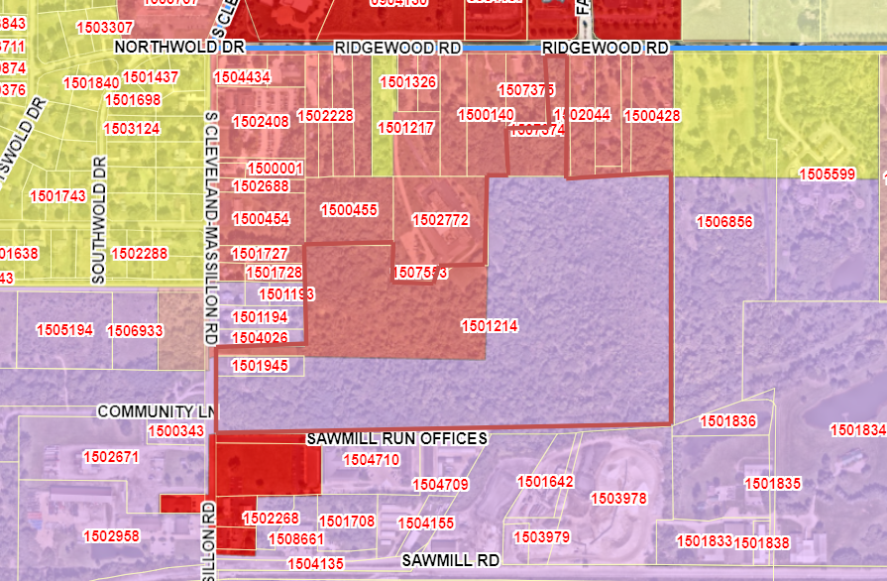
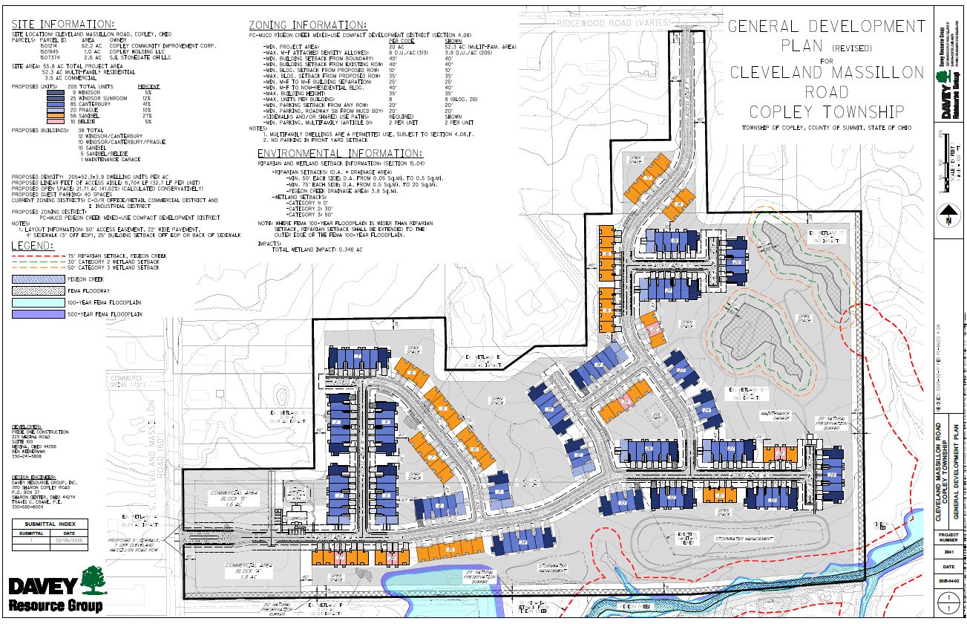

PROJECT DESCRIPTION
The applicant is seeking approval of a Major Site Plan for the purpose of constructing 202 multifamily units and 3.5 acres of commercial development. The total land area is 55.8 acres.
The site is comprised of 50’ private drives consisting of a 22’ access driveway, tree lawn and 4’ sidewalks on both sides of the aisle.
The proposed residential density is 3.9 dwelling units per acre.
The residential project will be constructed in 3 Phases:
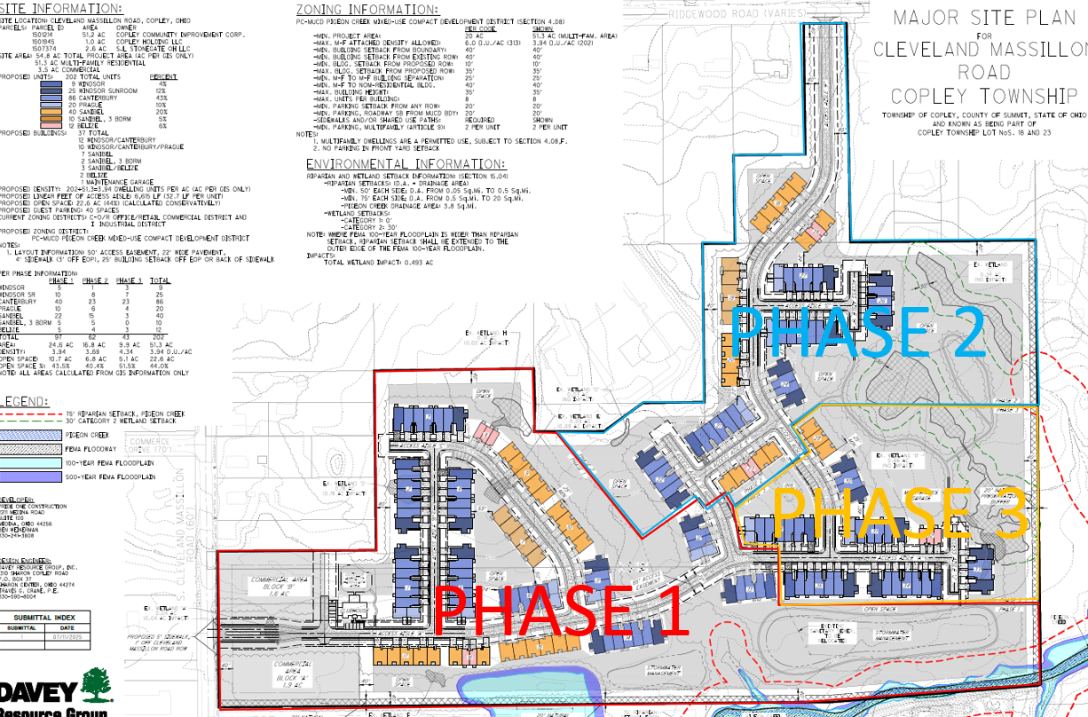
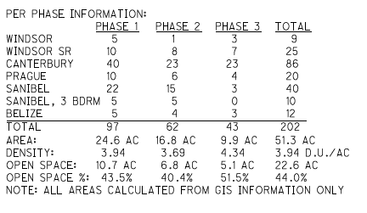

RESIDENTIAL PRODUCT
The units will be comprised of premium vinyl lap, board and batten and shake siding with stone veneer.
The residential product is inclusive of 37 buildings and the following multifamily products:
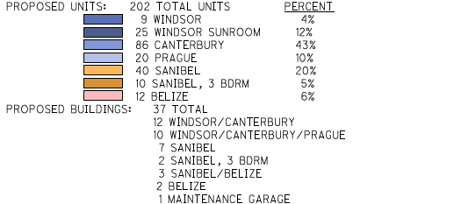
WINDSOR (34)/ CANTERBURY (86)
- 1 Story
- 2 Bedrooms
- 2-Car Garage
- Some Windsor Units to include a sunroom

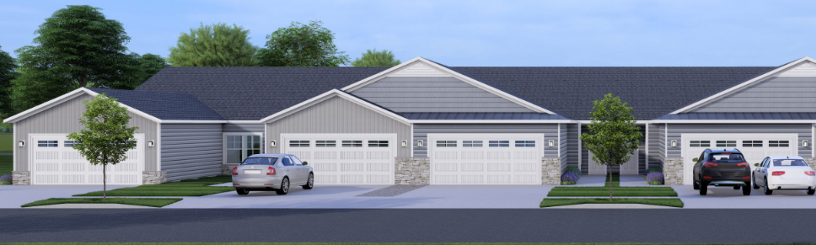
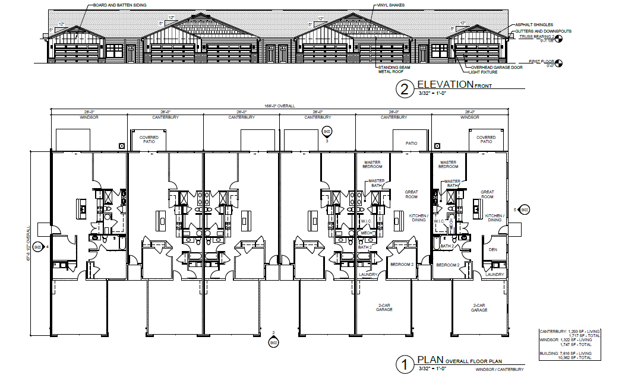
PRAGUE (20)
- 1 Story
- 1 Bedroom
- 1-Car Garage

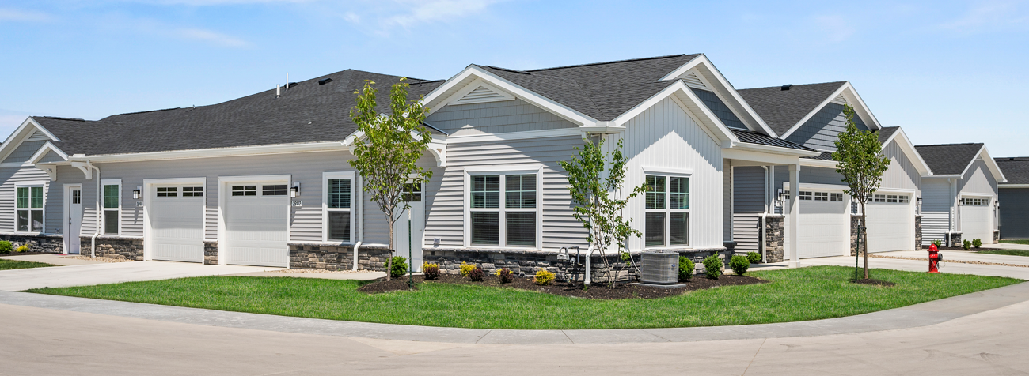
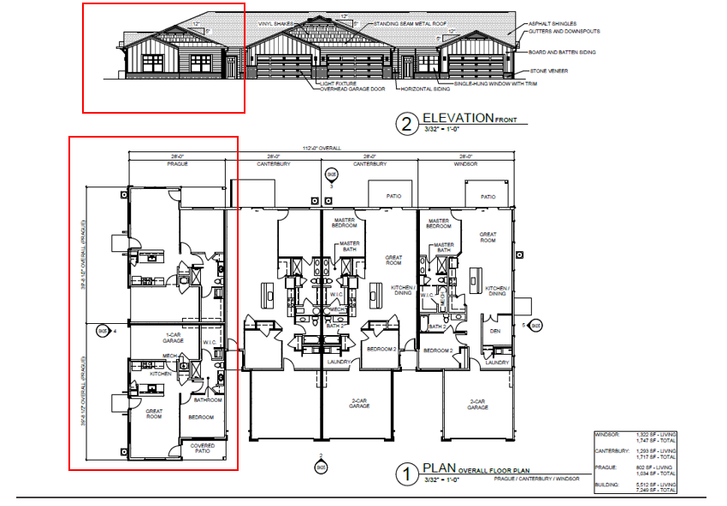
BELIZE (12)
- 2 Story
- 3 Bedroom
- 1-Car Garage

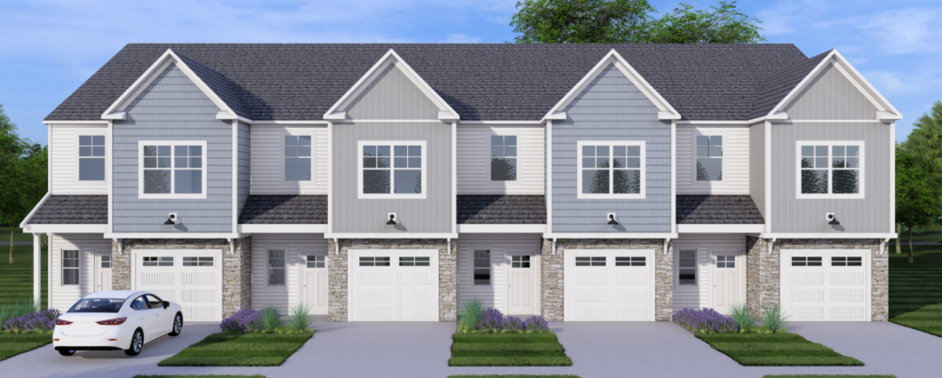
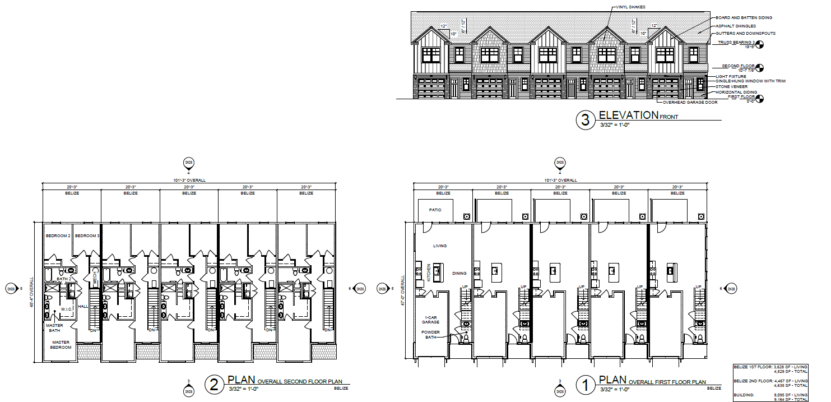

SANIBEL (40)/SANIBEL 3 BR (10)
- 1 Story
- 2 Bedroom/3 Bedroom
- 2-Car Garage

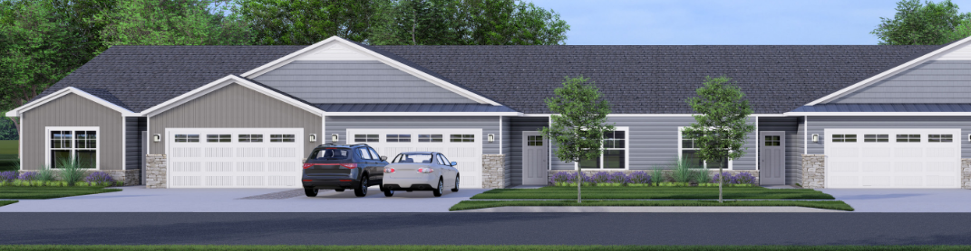

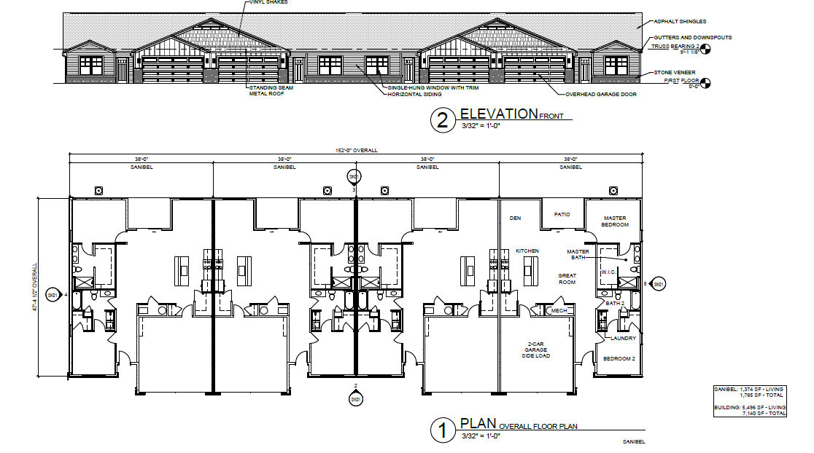

Amenities
The community will include the following resident amenities:
- Outdoor Hardscape Area
- Clubhouse
- Community Pool
- Walking Trail
- Sidewalks
- Dog Park
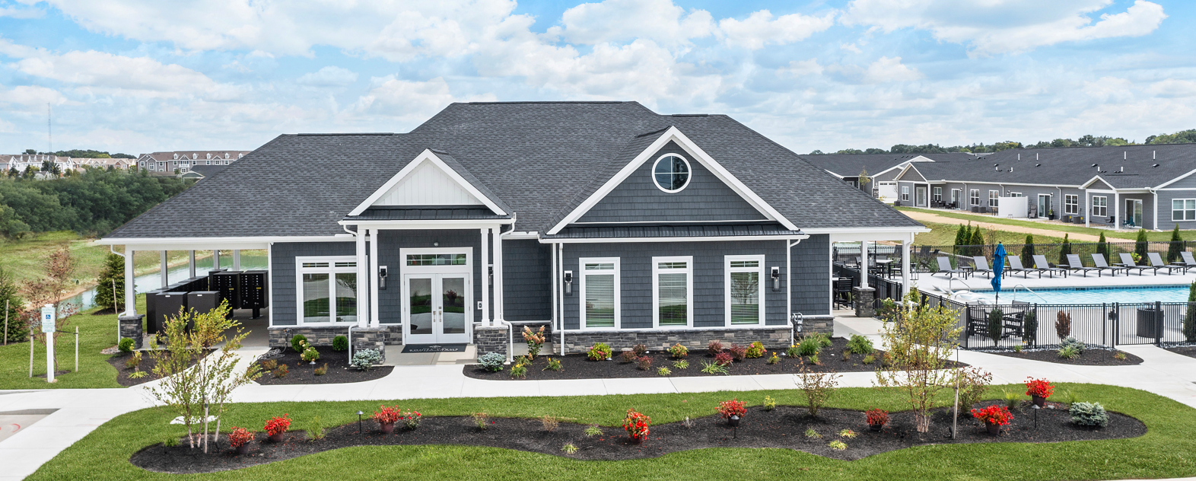
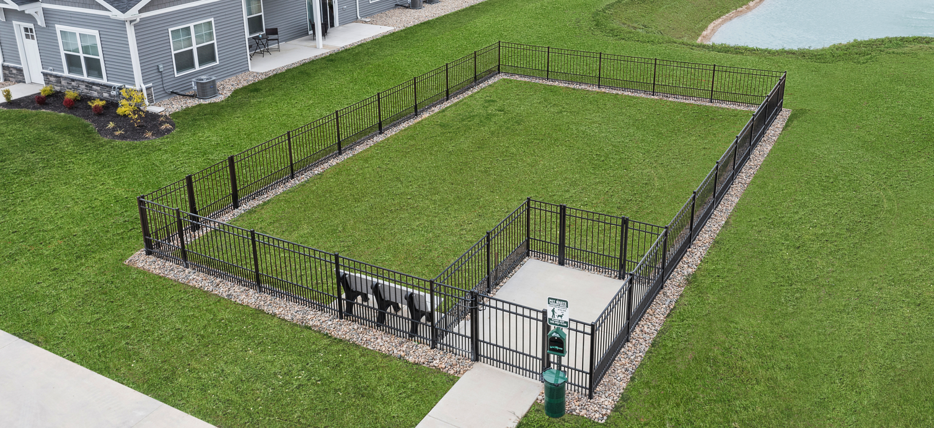
Commercial Product
The commercial product is inclusive of 3.5 acres to be built. The parcels are expected to provide a building envelope of approximately 20,000 square feet in overall area. The commercial units will serve as the gateway into the residential community.
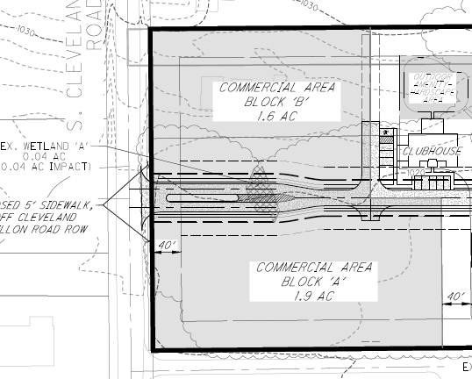
Accessory Uses/Structures
Lighting-The site will be illuminated with residential coach lights located on each side of the garage. Street lights are not planned for this community.
Sales Office-A leading office will be located inside of the Club House
Signs-Anticipate development sign(s) located within the boulevard at main entrance. TBD

Article 4-Residential Districts

Section 4.08 Pigeon Creek Mixed Use Compact Development (MUCD) Overlay

Permitted Uses
It is the intent of these regulations that the Pigeon Creek Mixed Use Compact Development District may contain a mixture of uses and a variety of building types (multi-family and commercial) not otherwise allowed in a given underlying zoning district and that such deviations may be allowed under circumstances where the Architectural Review Board determines it to be sufficiently advantageous and appropriate to grant such permission to depart from the normal requirements of the applicable zoning district. As a guide to the Architectural Review Board in making such determinations, the Pigeon Creek Mixed Use Compact Development District may contain, but is not strictly limited to, one or more of the uses specifically enumerated below in Table A.

Table A Permitted Uses

- Residential:
a. Multifamily dwellings with not more than 8 units attached | P**
b. Congregate living facility | P*
2. Offices:
a. Offices including administrative, medical, business and professional | P
b. Sales offices with only samples of products | P
3. Retail/Services:
a. Retail establishments in completely enclosed buildings | P
b. Banks | P
P = use is permitted; P* = use is permitted subject to 4.06 I.
** Provided that the dwelling units are structurally attached to one another, side by side, and erected as a single building, each dwelling unit being separated from the adjoining unit or units by a party wall without openings extending from the basement floor to the roof with each unit including separate ground floor entrances, services and attached garages. No more than 8-units attached.

  - Conditionally Permitted Uses. Uses that are conditionally permitted in Commercial Neighborhood-Retail District outlined in Article 7, excluding the following: Gasoline Service Station (Full or Multi-Use), Transient Hotels, Life Care Facility, and Wind Turbines.

  - Accessory Uses. The following uses that are accessory to an establishment in a PC-MUCD district shall be permitted when they are clearly incidental to and subordinate to, meet the setbacks of, and are located on the same lot as the principal building or use.

    - Off-street Parking. Off-street parking as regulated in Article 9.
        - Guest Parking: 40 spaces
        - Tenant Parking: 2 per dwelling unit

    - Fences and Walls. Fences and walls may be erected in a PC-MUCD District in compliance with this Resolution.
        - There are no fences, walls currently proposed for this project

    - Accessory Facilities for Residents of Development. Community centers, pools, tennis courts, and other indoor and/or outdoor recreational and/or community gathering places typically associated with residential dwellings for use by residents of the PC-MUCD District.
        - Plan inclusive of a Clubhouse, Community pool, Dog Park

    - Signs. Signs as regulated by Article 8.

Density

  - Density for Residential Development.

Multifamily Dwellings - Maximum density shall be 4.5 dwelling units per acre
Provided that the dwelling units are structurally attached to one another, side by side, and erected as a single building, each dwelling unit being separated from the adjoining unit or units by a party wall without openings extending from the basement floor to the roof with each unit including separate ground floor entrances, services and attached garages. No more than 8-units attached
    - Plan inclusive of 3.94 Units per Aces
    - Maximum number of attached units: 8
    - Minimum number of attached units: 3

Development Standards

Table B
a. Minimum Setback of New Buildings from Project Boundaries  - Plan inclusive of 40’ setback from all property lines | 40 feet
b. Minimum Setback of New Buildings from Existing Public Street Rights-of-Way dedicated as of the date the PC-MUCD general development plan application is submitted  - Plan inclusive of 40’ setback from existing right-of-way along S. Cleveland Massillon and Ridgewood | 40 feet
c. Setback of New Buildings from proposed public street Right-of-
Ways within the PC-MUCD OR edge of pavement from proposed private streets
1) Minimum | 10 feet
2) Maximum  - Minimum setback per plan: 27’  - Maximum setback per plan: 35’ | 35 feet

      - All new multi-family dwellings and non-residential buildings: The minimum separation between multi-family dwelling units shall be 25 feet and 40 feet from all other non-residential buildings.
- Minimum separation between dwelling units per plan: 25’
- Minimum dwelling unit from non-residential will be no less than 40’

  - Building Height: The maximum height of any principal building shall be 35 feet unless a greater height is specifically authorized by the Architectural Review Board and with the approval of the Fire Chief.
- 1-Story Dwelling: 20’
- 2-Story Dwelling: 30’

  - Parking and Roadway Setbacks: Off-street parking areas and roadways shall be screened according to Articles 9 and 14 and shall comply with the following setback requirements:-PROVIDED FOR UPON CONSTRUCTION OF COMMERICAL STRUCTURES

    - Off-street parking areas shall be located to the side or rear of buildings and shall not extend into a front yard.

    - All off-street parking areas shall be set back from an existing or proposed right-of-way a distance not less than 20 feet.-

    - All off-street parking areas and roadways shall be set back from all other boundaries of the PC-MUCD project a distance not less than 20 feet.

  - Sidewalk and/or Shared Use Path – New buildings, structures, and parking areas shall include the installation of a sidewalk and/or shared use path. The sidewalk and/or shared use path shall connect to similar facilities on adjacent property. In special cases, such as if no adjacent property sidewalk or shared use path exists, the facility type(s) and location shall be approved by Copley Township Community and Economic Development Staff via Site Plan review. See Section 13 of this document.-Internal Sidewalks, at a minimum of 4’ in overall width provided per plan; Copley Township defines sidewalks as a paved path 5’ minimum width, of which 4’ is unobstructed for pedestrians; 5’ External sidewalk along S. Cleveland Massillon is provided for

Supplemental Requirements
See report for Landscape Specifications
  - A minimum of 40% open space.

    - Plan provides for 44% open space

  - The Architectural Review Board may impose additional conditions on uses to ensure the uses are consistent with the intent of these regulations.

  - Buffering Between Residential and Industrial Uses
    - Natural Preservation Buffer: When a residential use abuts an industrial use, a 20 foot wide tree preservation buffer shall be maintained along the property boundary. The buffer shall consist of existing vegetation to ensure a continuous natural screen between the two uses.
      - Plan provides for a 20’ natural preservation buffer

    - If the required Natural Preservation Buffer cannot be maintained due to site conditions or prior development, a 6-foot-tall opaque fence shall be installed along the 20’ Natural Preservation Buffer line, extending the distance where the Natural Preservation Buffer could not be satisfied.

Modifications
Modifications may be granted by the Township Architectural Review Board only when it determines that certain standards set forth in this Section do not or should not apply specifically to the circumstances of a particular project and when the alternative method proposed to achieve the objectives of the numerical standard is equal to or better than the strict application of the specified standard. The Township Architectural Review Board may modify such standard to an extent deemed just and proper, provided that the granting of such relief shall be without detriment to the health and safety of the community and without detriment to or impairment of the intent of this Section.

A modification shall only be considered by the Architectural Review Board during the review and approval procedures for a development plan.

Development Plan Review
  - The establishment of the PC-MUCD district requires that the following steps shall be completed concurrently:

    - Application for zoning map amendment is submitted, pursuant to this Resolution.-COMPLETE

    - Application for review of the general development plan, pursuant to this Resolution.-COMPLETE

  - Additional development requirements, whether standards or criteria, formulated to achieve the objectives of the PC-MUCD District may be established during the Architectural Review Board’s review of the General Development Plan. Any such development requirements adopted with such plan shall become binding land use requirements for the proposed development.

  - After a General Development Plan is approved for a PC-MUCD project, the applicant shall prepare and submit a Final Development Plan for either all or a phase of the development.

  - After approval of the Final Development Plan has been obtained from the Architectural Review Board, a Zoning Certificate may be obtained.

ARTICLE 16: TREE REMOVAL/PRESERVATION
TREE INVENTORY
Overview: Applicant is requesting approval of a Limited Tree Survey provided by CEC (Civil & Environmental Consultants, Inc). The purpose of the survey is demonstrate general woodland quality and habitat type including canopy coverage and tree quality.

Method: Identification of nine (9), 30’ radius tree canopy plots. Each plot spaced a minimum of 500’ to accurately characterize the larger vicinity.

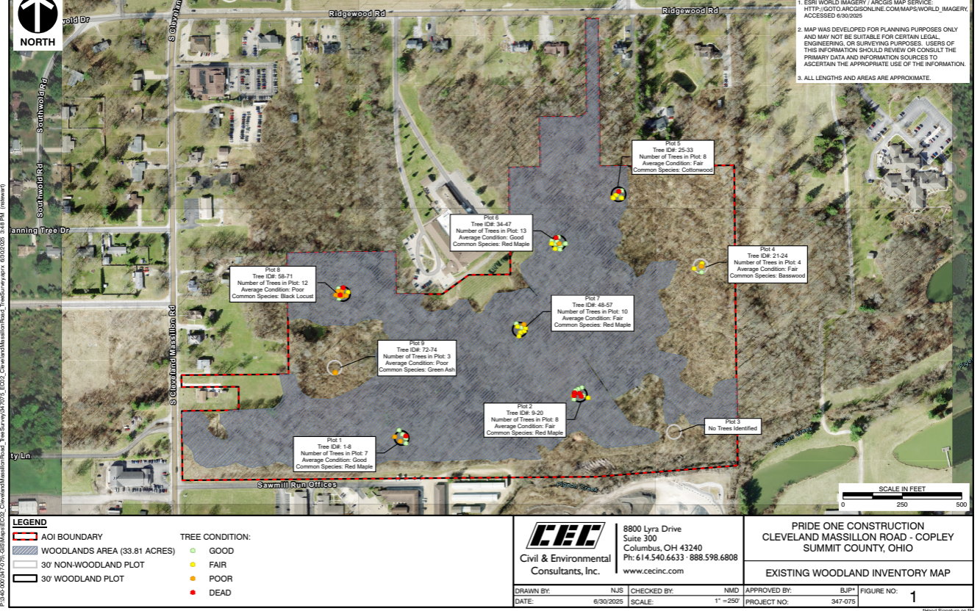

PLOT 1
Plot 1 (Woodland) exhibited good, poor, and dead conditions and was primarily dominated by Red
Maple, which made up more than 50% of the total canopy coverage. The understory was dominated
by Green Ash and Virginia Creeper.
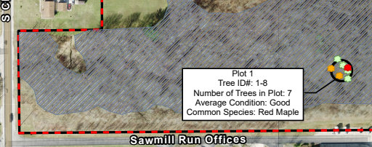

PLOT 2
Plot 2 (Woodland) exhibited good, fair, and dead conditions and was primarily dominated by Red Maple, which made up more than 50% of the total canopy coverage. The understory was dominated by Green Ash and Multiflora Rose.
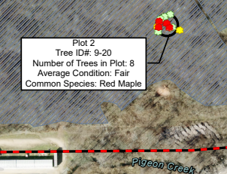

PLOT 3
Plot 3 (Non-Woodland) exhibited no trees greater than 6" DBH. The plot was dominated by tall
Goldenrod.
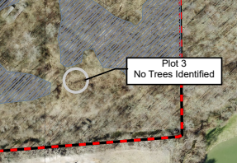

PLOT 4
Plot 4 (Non-Woodland) was dominated by an understory of Red Oak and Eastern Poison Ivy. The tree
stratum (>6" DBG) exhibited good, poor, and dead conditions and was primarily dominated by
Basswood, which did not make up more than 50% of the total canopy coverage.
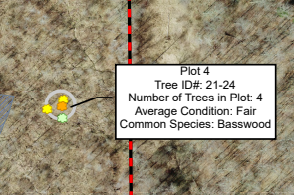
PLOT 5
Plot 5 (Woodland) exhibited good, fair, and dead conditions and was primarily dominated by Eastern Cottonwood
which made up more than 50% of the total canopy coverage. The understory was dominated by Eastern Poison Ivy.
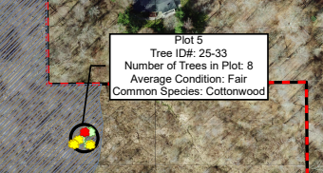
PLOT 6
Plot 6 (Woodland) exhibited good, fair, poor, and dead conditions and was primarily dominated by Red Maple,
which made up more than 50% of the total canopy coverage. The understory was dominated by Eastern Poison Ivy
and Green Ash.
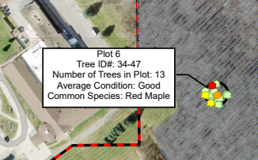
PLOT 7
Plot 7 (Woodland) exhibited good, fair, and poor conditions and was primarily dominated by Red Maple, which
made up more than 50% of the total canopy coverage. The understory was dominated by Green Ash and American
Beech saplings.
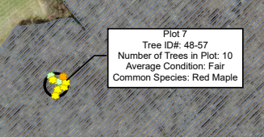
PLOT 8
Plot 8 (Woodland) exhibited good, fair, poor, and dead conditions and was primarily dominated by Black Locust,
which made up more than 50% of the total canopy coverage. The understory was dominated by Virginia Creeper
and Eastern Poison Ivy.
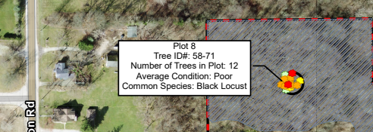
PLOT 9
Plot 9 (Non-Woodland) was dominated by an understory of Buckthorn, Multiflora Rose, and Virginia Creeper. The
tree stratum (>6" DBH) exhibited fair and poor conditions and was primarily dominated by Green Ash, which did not
make up more than 50% of the total canopy coverage.
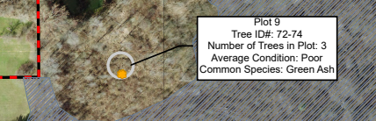

PRESERVATION RELIEF
Total Acreage | 55.8 Acres
Permitted Clearing | 27.9 Acres
Requested Clearing | 33.8 Acres
Exceeds | 5.9 Acres
Relief Requested | Fee in Lieu of: Option A Fair Market Value
Summit County Fiscal Assessed Land Value (Parcel 1501214) $251,260/52.2 | $4785.90
Fee per Acre $4785.90 x 5.9 | $28,236.81*

FOR CONSIDERATION:
Fee in lieu of deposit to assist in future plantings for future sidewalk installation within the Township

TREE PRESERVATION PLAN/TREE CLEARING PERMIT
Upon application of a Tree Clearing Permit, the applicant is required to provide a Tree Preservation Plan inclusive the following in addition to an approved Tree Survey and Relief Request:
- Tree Protection Zone
- Critical Root Zone
- Tree protection fencing
- Tree protection signage
- Demonstration of method used for tree protection
ARTICLE 14: LANDSCAPE
Summary: The applicant’s plan satisfies the requirements as stated in Article 14. Data provided in the linear frontage and plantings is an estimate to be confirmed with engineered drawings.
Tree Planting Totals:
Type | Quantity | Primarily
Deciduous | 123 | October Glory Red Maple, American Yellowwood, Tulip Poplar
Evergreen | 97 | Norway Spruce
Flowering Trees | 98 | Eastern Redbud, Japanese Tree Lilac
Street Trees | 277 | Red Sunset Maple, Autumn Blaze Maple, Princeton Sentry, Littleleaf Linden

Section 14.09
Requirement: 30% Native, Maximum number of any one species-30%
Trees Met- Glory Red Maple, Tulip Poplar, American Sycamore, Eastern Redbud, Dogwood, Sunset Maple
Shrubs-Not Met- Ninebark
Grasses-Not Met

For Consideration:
- Substitutions: White Pine. Per ARB recommendations
- Addition of Evergreen trees along S. Cleve Mass and Ridgewood
- Require evergreen planting buffer along any property line abutting a residential dwelling
- Call out mounding on plan

14.04 Landscaping Along Streets
A. Within the Subdivision One (1) deciduous tree for every twenty-five (25) feet of street frontage on each side of the street
STREET | FRONTAGE | REQUIRED | PROVIDED | TYPE
AISLE A | 2000 | 80 | 91 | Lilac, Scarlet Oak
AISLE B | 540 | 22 | 16 | Red Maple, Tulip
AISLE C | 1000 | 40 | 34 | Littleleaf Linden, Red Maple, Tulip
AISLE D | 475 | 19 | 15 | Red Maple, Tulip
AISLE E | 240 | 10 | 7 | Littleleaf Linden
AISLE F | 1600 | 64 | 78 | Yellowwood, Lilac, Swamp White Oak, Red Maple,
AISLE G | 200 | 8 | 10 | Littleleaf Linder
AISLE H | 150 | 6 | 9 | Red Sunset Maple
AISLE J | 150 | 6 | 12 | Red Sunset Maple
 |  | 255 | 272

B. For street along the perimeter of the subdivision
2. Three (3) foot high berm with (3) deciduous trees and six (6) shrubs for every 100 linear feet of frontage
FRONTAGE | REQUIRED | PROVIDED | PLANTINGS
S Cleveland Massillon Road: 450’ | 14 Deciduous Trees; 27 shrubs | 19 Trees; 114 Shrubs | American Sycamore, Crabapple, Red Sunset Maple; Boxwood, Juniper, Viburmum
Ridgewood Road: 125’ | 4 Deciduous Trees; 8 Shrubs | 4 Trees; 22 Shrubs | Prairie Rose Crabapple; Juniper, hydrangea

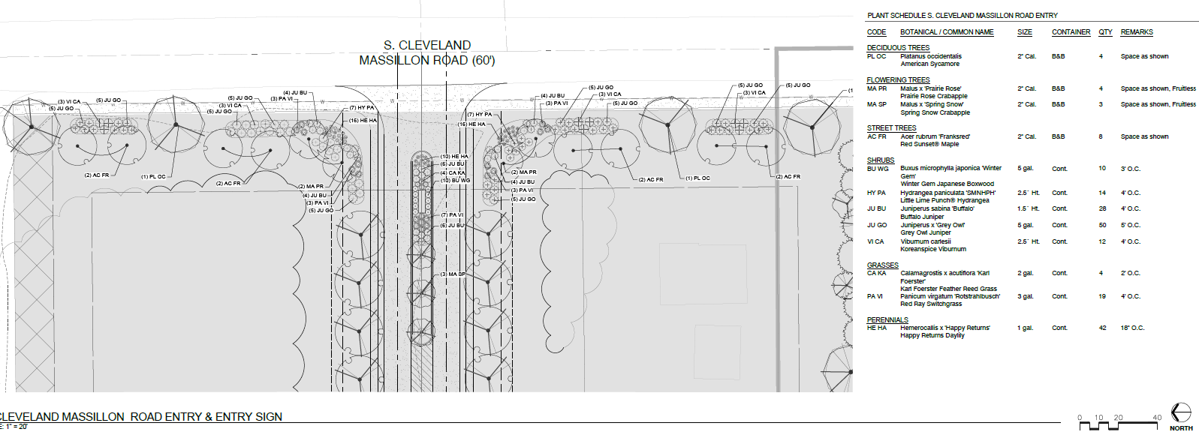
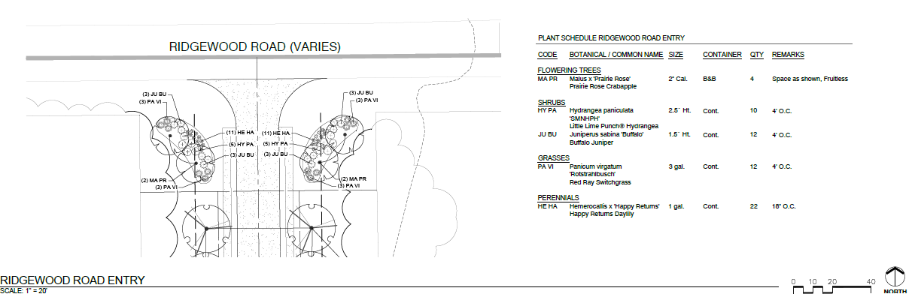

A14.06 Building Façade Landscaping
A. 75% of building façade
C. Three (3) trees for every 100 lineal feet of façade
The following are typical planting installs for each unit façade:
Trees: Autumn Serviceberry, Milky Way Dogwood, Perfect Purple Crabapple
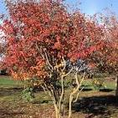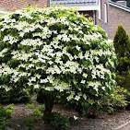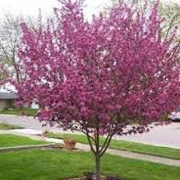
Shrubs: Boxwood, Cypress, Hydrangea, Ninebark, Globe Blue Spruce, Knock Out Red Rose, Spiraea, Weigela,
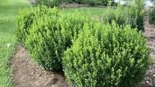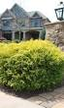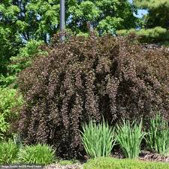
Perennials:Coneflower, Daylily, Liflyturft, Catmint, Montauk Daisy
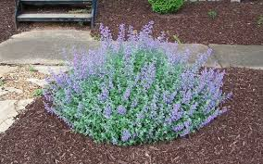
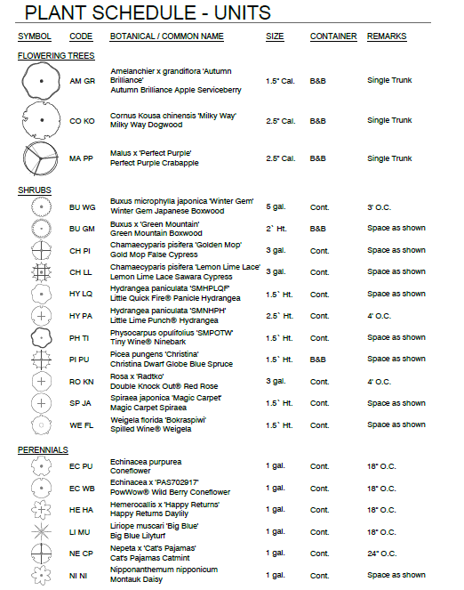
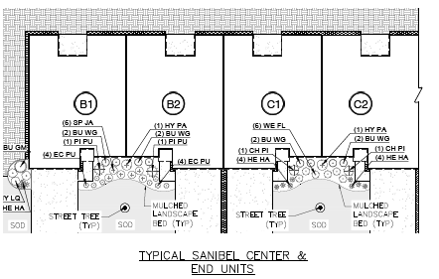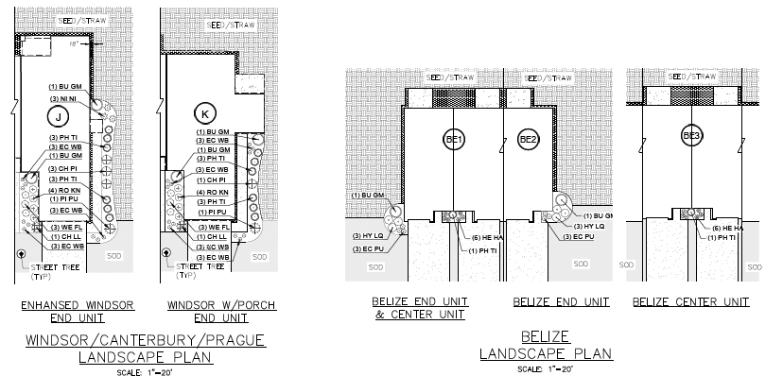

Article 4: Section 4.07 I 3. Buffering
20’ Natural Landscape Buffer where Residential Meets Industrial (southern property line)
The applicant has provided for a 20’ buffer. In addition to the natural vegetation, the applicant proposes the following:
- 45+ Tree Plantings comprised of Norway Spruce, Dogwood, Tulip Poplar

Miscellaneous Plantings
The applicant has provided for 100+ additional plantings inside of the Open Space areas, Dog Park, Clubhouse and Walking Trail located within the community and along the perimeter areas. Plantings include Tulip Poplar, Scarlet Oak, Black Tupelo, Norway Spruce
SIDEWALK
The applicant is providing for a 5’ sidewalk along S. Cleveland Massillon Road.
For consideration: Change to an 8’ shared use path, and install along Ridgewood Road
WETLAND DELINEATION/JURISDICTIONAL DETERMINATION
A Wetland Delineation was performed by CEC and submitted to the Army Corp of Engineers on December 5, 2024. A total of 2.01 acres of wetlands have been identified with a potential impact of up to .49 acre. Jurisdictional Delineation received for Parcels 1501214 & 1501945 Require delineation for Ridgewood Road parcel 1507374-In progress
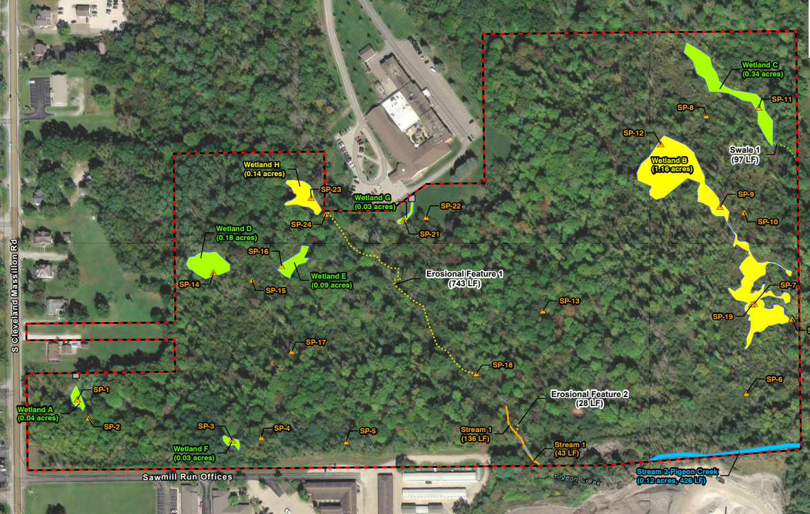
Identified:
- Seven (8) wetlands (Wetlands A through H), totaling 2.01 Acres

Wetland A: .04
Wetland B: 1.16
Wetland C: .34
Wetland D: .18
Wetland E: .09
Wetland F: .03
Wetland G: .03
Wetland H:
- Two (2) streams (Pigeon Creek and Stream 1), totaling approximately 641 linear feet (LF);
- Two (2) erosional features (Erosional Features 1 and 2), totaling approximately 771 LF;
- One (1) swale (Swale 1), totaling approximately 97 LF.

APPROVED JURISDICTIONAL DETERMINATION
(DOES NOT INCLUDE PARCEL 1507374 (RIDGEWOOD RD))
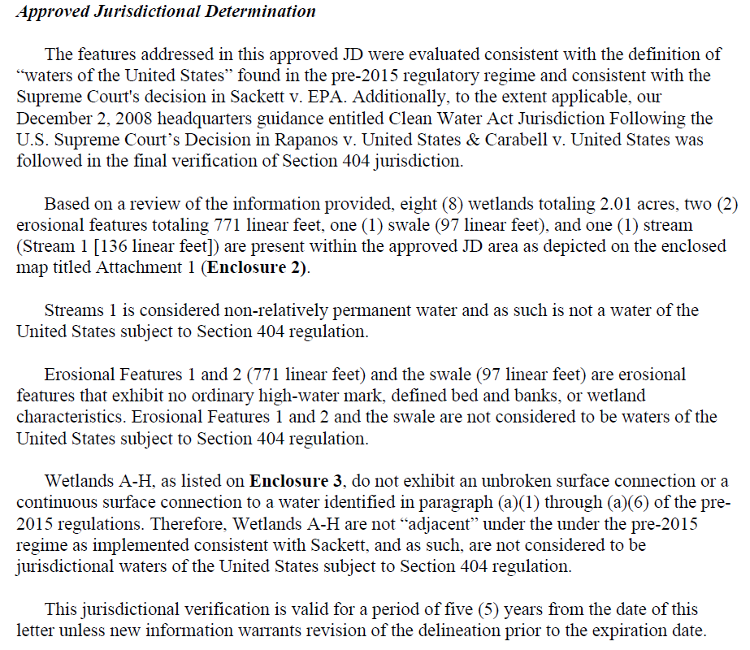

POTENTIAL IMPACT
At this time, Preliminary findings indicate no impact to Riparian. Impact to wetlands appear to be isolated and therefore not under the discretion of the Riparian regulations.
- Wetland A, B, C, G: No Impact
- Wetland D: 0.18 A
- Wetland E: 0.09 A
- Wetland F: 0.03 A
- Total Potential Impact: 0.493 A

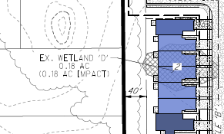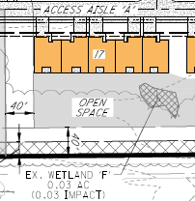
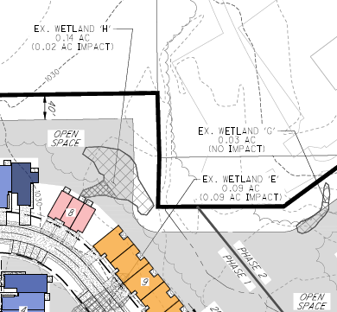
A cursory review was provided by Summit Soil & Water Conservation District: One potential impact for wetland C. If that wetland is a cat-3 wetland, then it would get the 50’ buffer which does show a small potential impact. Receive all UASE/OEPA permits done before submission.
TRAFFIC IMPACT STUDY
A Traffic Impact Study was completed by MS Consultants Inc on June 5, 2025. The study has been submitted to the Summit County Engineers Office and the City of Fairlawn for review.
Findings of the study include the following:
As a result of the development, a southbound left turn lane with 175’ of storage length should be
constructed on Cleveland-Massillon Road at the proposed site access point (Site Drive A). No
improvements are recommended at any other study area locations to mitigate site traffic.
A cursory review was provided by Summit County Engineers Office as follows:
- Watch the separation from the northerly access drive and Fairlawn Corporate Parkway. If the two could be aligned, that would be ideal.
- Interconnection with the driveway immediately to the south is something that should be encouraged.

Copley Township recommends installation of turn lane with Phase 1 development.
ACCESS INGRESS/EGRESS
The plan calls for a primary access at S. Cleveland Massillon Road and a secondary access at Ridgewood Road.
The access drives are private. The drives will be 50’ in overall width comprised of 22’ of pavement for two way traffic flow. Article 9 requires 24’ aisle width for two way traffic flow.
Add traffic calming measures along Aisles A & F to the plan.

AFFECTED PARTIES/PUBLIC COMMENTS
Parcels 1502061/1504943: Request evergreen buffer along rear property lines
Parcel 0903921: Request review of Traffic Impact Study and consideration for traffic pattern along Ridgewood Road
PER THE REVIEWING AGENCY/DEPARTMENT
Copley Township Architectural Review Board | Review pending
Copley Township Fire Department | 1/30/2025  Cursory Review  No objections  Applicant to provide for turn radius per regulations  7/31/2025
Copley Township Service Department | Cursory Review  No objections
Copley Township Police | 2/4/2025  Cursory Review  No objections  Plan recommendations as follow:  - Provide for outdoor activity area(s) for children living in the multifamily community  - Provide for traffic calming measures along Aisle A & F (Show on site plan)  7/31/2025  - Provide sufficient off-street parking and permit no on street parking  - Add Guest Parking along A & J
Summit County Soil & Water Conservation District | 1/28/2025  Cursory Review  No objections  Comments:  - Not many proposed riparian impacts save for a potential one for wetland C. If that wetland is a cat-3 wetland, then it would get the 50’ buffer which does show a small potential impact.  - Recommend all UASE/OEPA permits done before plan submitted for formal review
Akron Regional Air Quality Management District  Summit County Public Health | 3/5/2025  Provided most recent air permits for the Shelly asphalt plant that is currently located on Sawmill Road in Copley.  The permits are issued to ensure that air quality standards are met and that public health is protected.  Asphalt plants have inherent odors that are not regulated through these permits. Residents living downwind from the facility will be more affected.  Additionally, there are also fugitive dust sources associated with the asphalt plant such as plant roadways and parking areas and material storage piles. While the permits require control measures to minimize or eliminate visible emissions of fugitive dust, they do allow for a limited amount of visible emissions to occur.  3/11/2025  No specific recommended separation between this use and residential.
Ohio Environmental Protection Agency | 4/2/2025  As far as surface water impacts, there are very minimal concerns/comments we have. The thing we will need is a Permit to Install (PTI) from the proposed facility to either tie into sewers or put in a system for wastewater treatment. Depending on what type of system goes it, it may need to be permitted through our agency.
Northeast Ohio Four County Regional Planning & Development Organization (NEFCO) | 3/11/2025  Required to tie into City of Akron Sewer per the NEFCO Clean Water Plan (208 Plan)

SUGGESTED MOTIONS and Authority to Proceed
ARCHITECTURAL REVIEW BOARD
The Copley Township Architectural Review Board motions to approve/approve with conditions/continue review/(deny)
- Approval conditioned upon satisfying all plan requirements and external jurisdictional agencies including but not limited to Army Corp of Engineers, Summit Soil & Water, Summit County Engineer, Centralized Services (Water/Sewer), Lot Consolidation
  - Site Plan
  - Landscape Plan
  - Tree Inventory Method
  - Fee In Lieu of

OR
- Continue pending submission of Final Jurisdictional Determination (and other documents as stated)

